CERS Tips and Tricks includes helpful explanations and resolutions to common issues that have been recently received by the CERS Technical Support Team.

To Sign In to CERS
Always use CERS Central to begin your session in CERS. Open your web browser and enter the following URL: https://cers.calepa.ca.gov/
Then, select the “Business Portal Sign In” button from the CERS Central Home page.

By accessing the business portal sign in page from CERS Central, the distribution domain will assign you to the currently active domain for a faster session. CERS Central also contains the latest updates and information for current alerts, outages, operating schedule changes, and announcements.
IMPORTANT- A facility CANNOT be deleted if submittals elements have been processed.
- Select Start / Edit Submittal
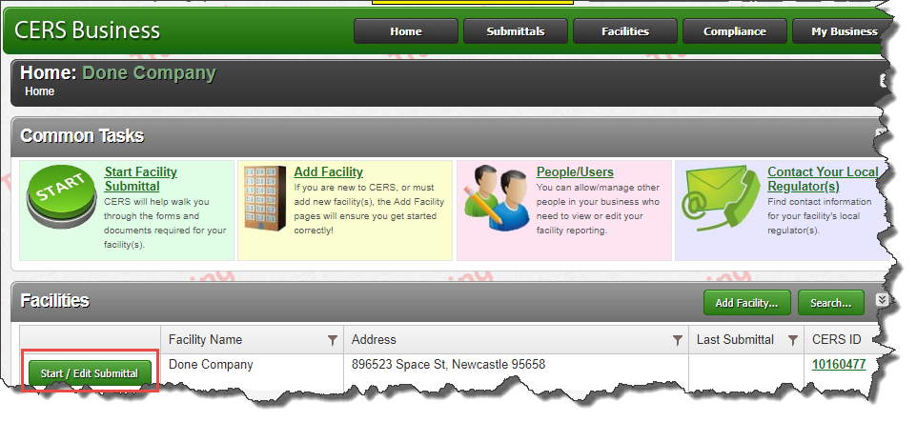
- Select My Business
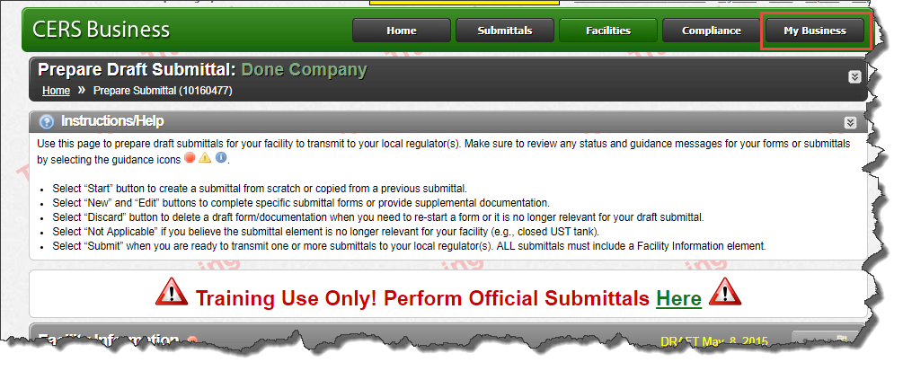
- Select Manage Facility
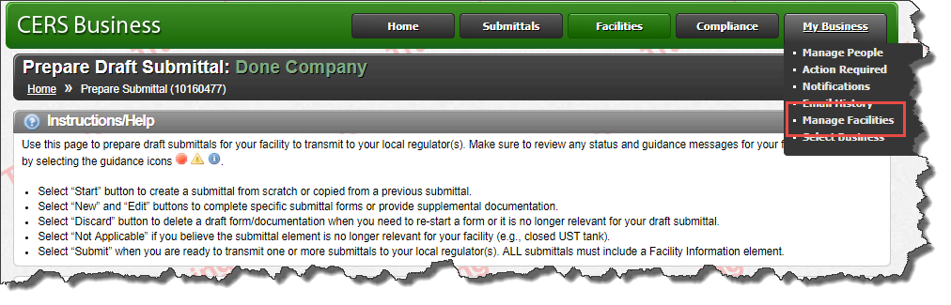
- Select Delete Facility Request
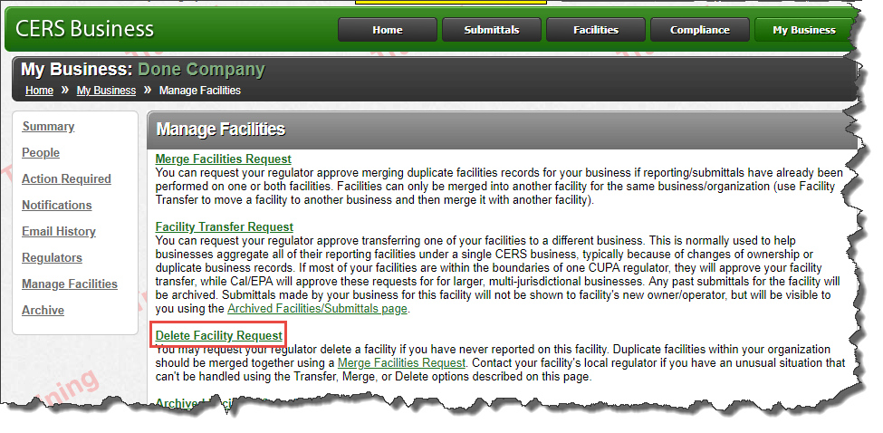
- Select CERS ID
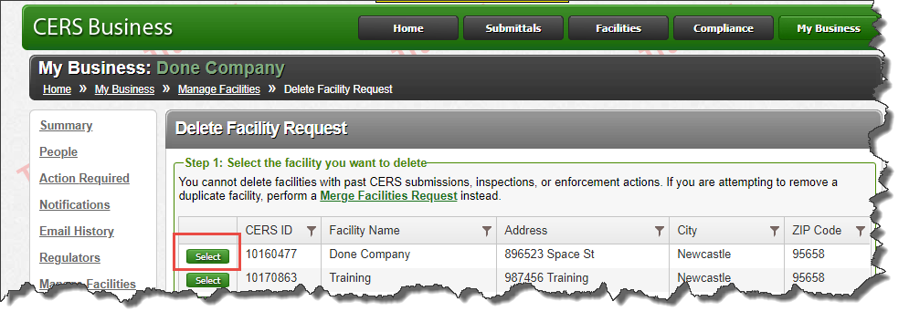
- Enter ‘Justification/Comments to Regulator (Please be specific)
