How to Update Regulator Directory Information in CERS

The following process outlines how to update Regulator Directory Information in the CERS Regulator portal.

Please Note: Lead User permissions to the regulator/agency are required, in order to edit the Directory Information section, in CERS.

- After signing in to the CERS Regulator portal, select the Regulators button from the menu bar.

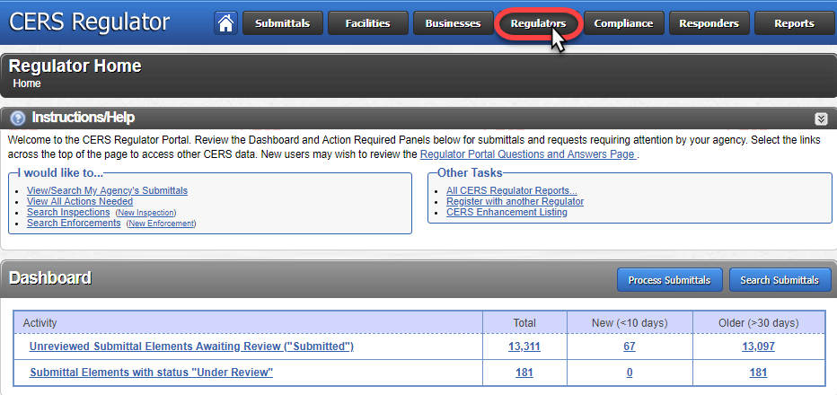

- Select your regulator/agency from the My Regulator(s) section.
Or use the Search, below, to locate your regulator/agency.

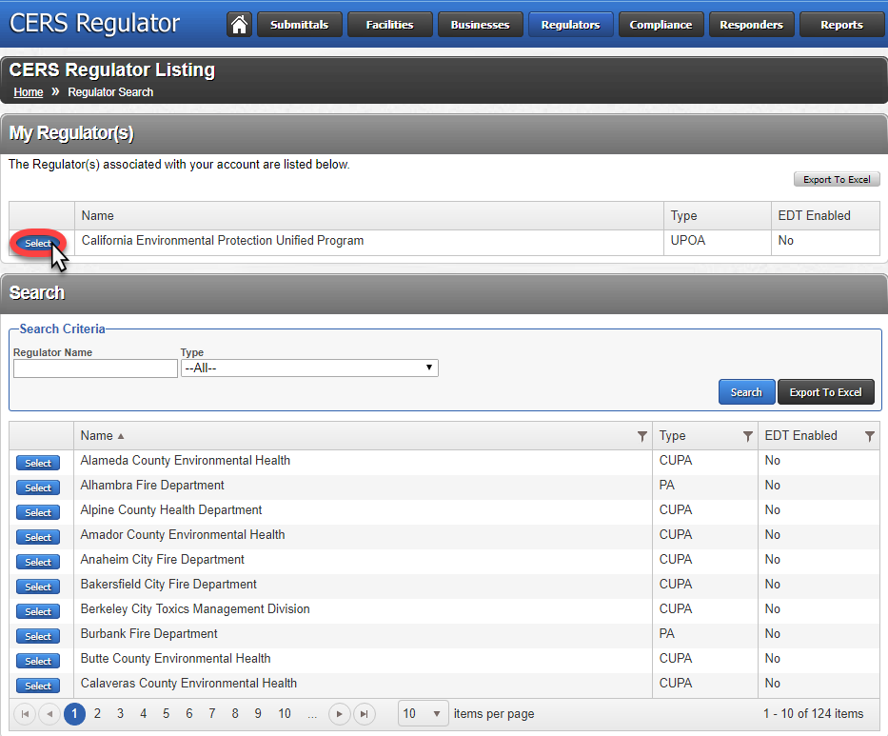

- After selecting a regulator/agency, you will be taken to a Summary page.
Select the Directory Info link from the menu, on the left.

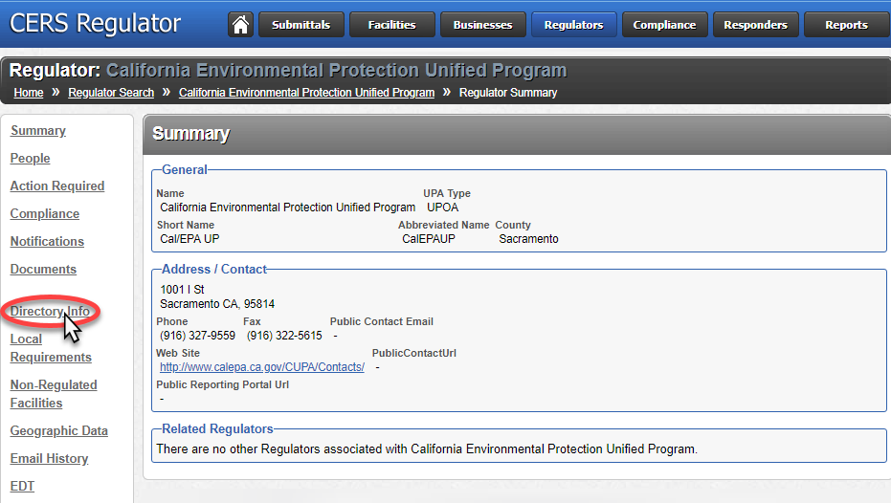
- Select the Edit button* below the UPA Directory Information section, on the right.

* Please Note: The Edit button will only be displayed if you have Lead User permissions to the regulator/agency, in CERS. To view your permissions, select the People link, from the menu on the left. Then select your name to view account permissions.

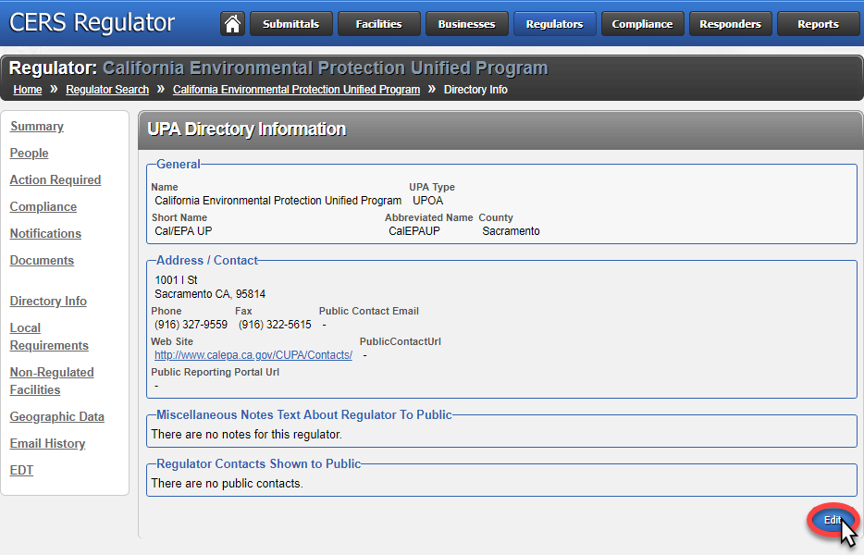

- Edit/update Directory Information, as needed.
Then select the Save button to update.

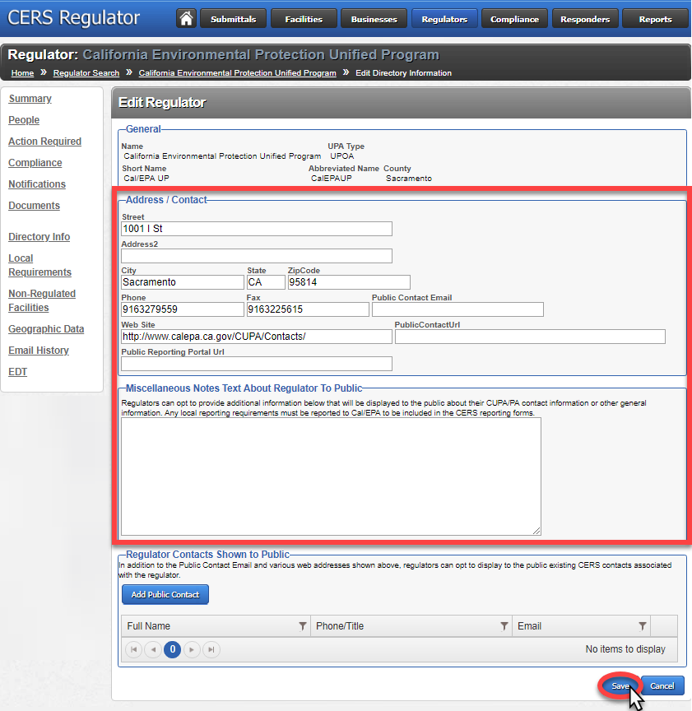

This will update the Regulator Directory Information in CERS, as well as the Unified Program Regulator Directory page (http://cersapps.calepa.ca.gov/Public/Directory/) – provided on both the CalEPA Unified Program (https://calepa.ca.gov/CUPA) and CERS Central (https://cers.calepa.ca.gov) public websites.

