Regulators can Create An CERS organization for a business
California Environmental Reporting System
CERS Regulator Portal Knowledge Base Help http://cers.calepa.ca.gov/
- Regulator signs into CERS Business Portal (production)
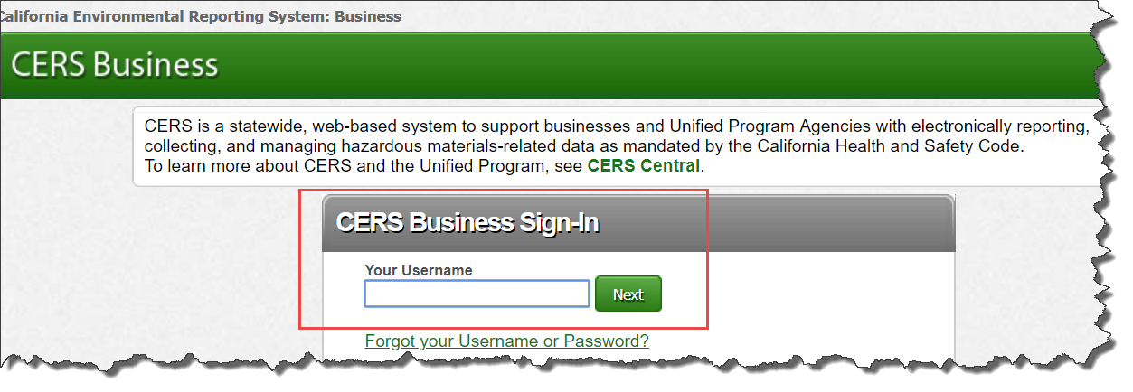
- Selects ‘Tool’ in the top tool bar
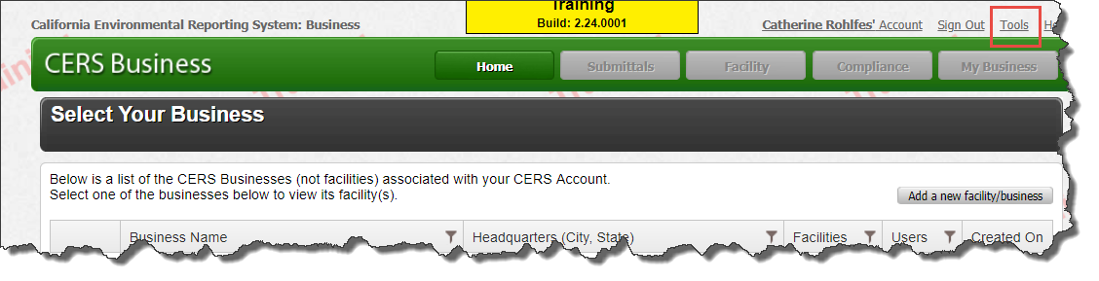
- Selects ‘Create CERS Business/Organization (no facility added)
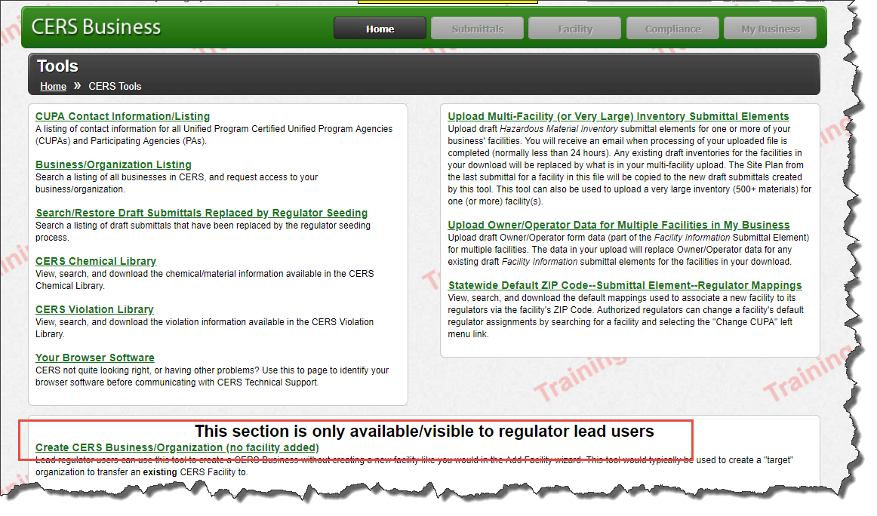
- Completes the ‘Organization Name’, ‘Headquarters’, ‘Origin’, ‘My Regulator’ fields, selects ‘Save’
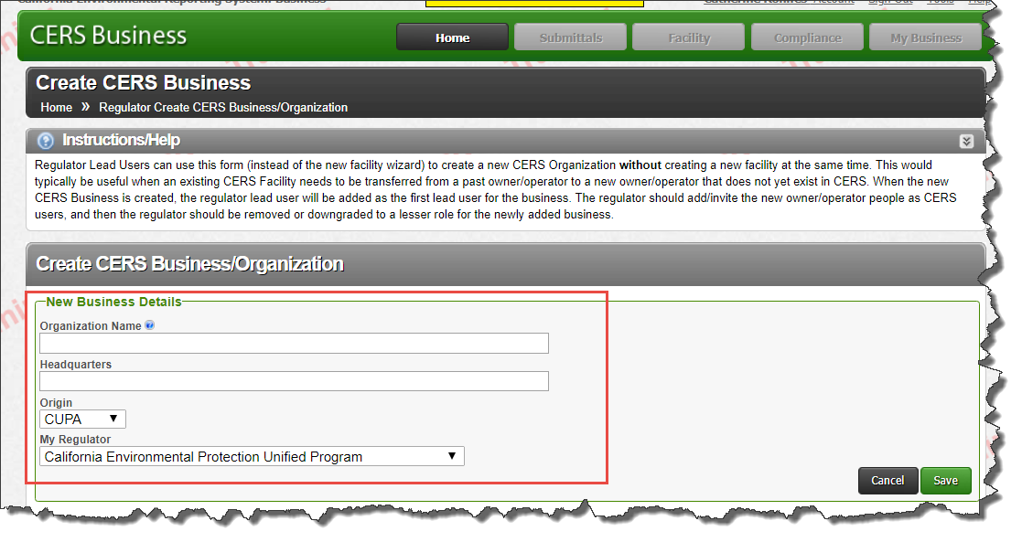
- Add Users/People to ‘Organization’
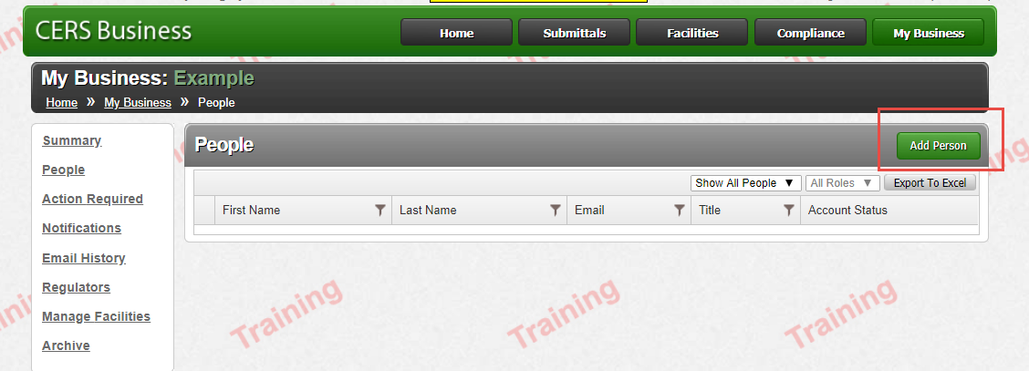

Add the ‘Facility’ to the ‘Organization’
- Sign into the ‘Regulator Portal’
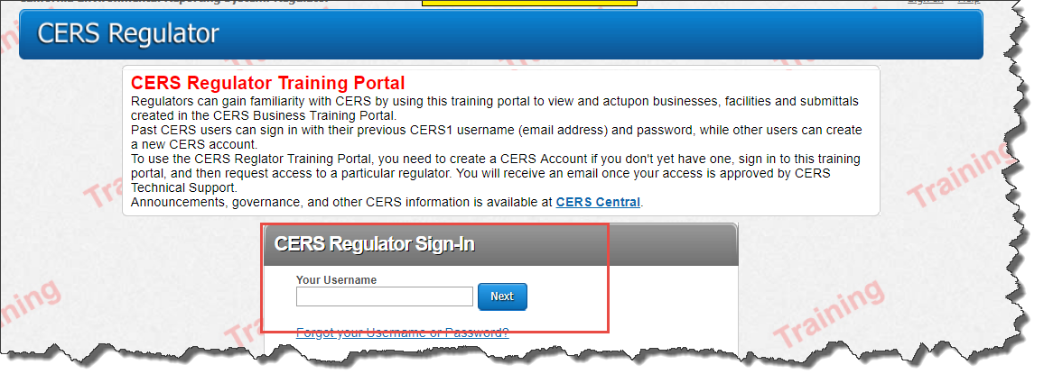
- ‘Facilities’ Tab search for facility
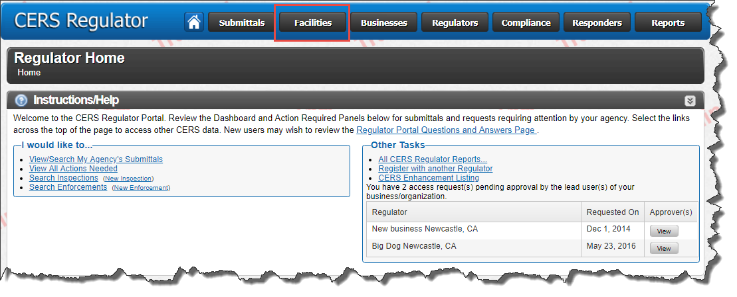
- Select ‘Facility’ to be transferred to the ‘Organization’
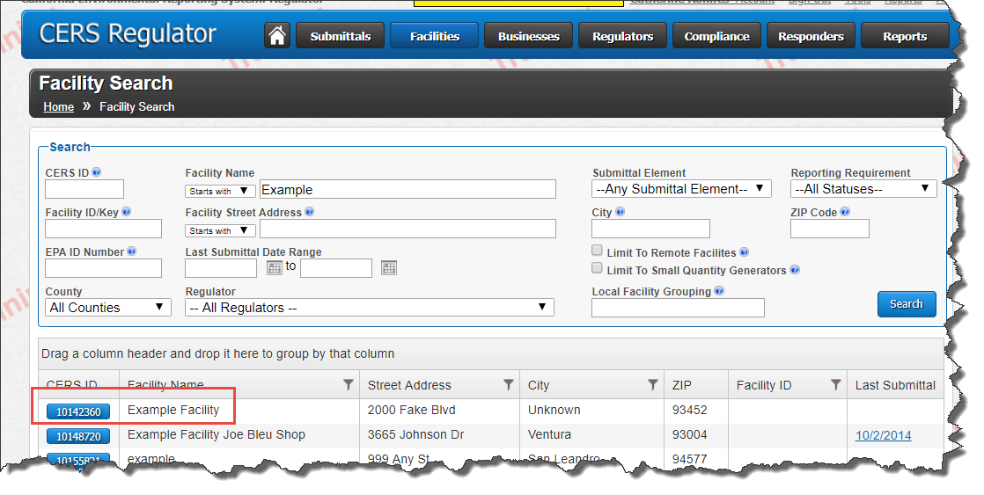
- Select ‘Manage Facility’
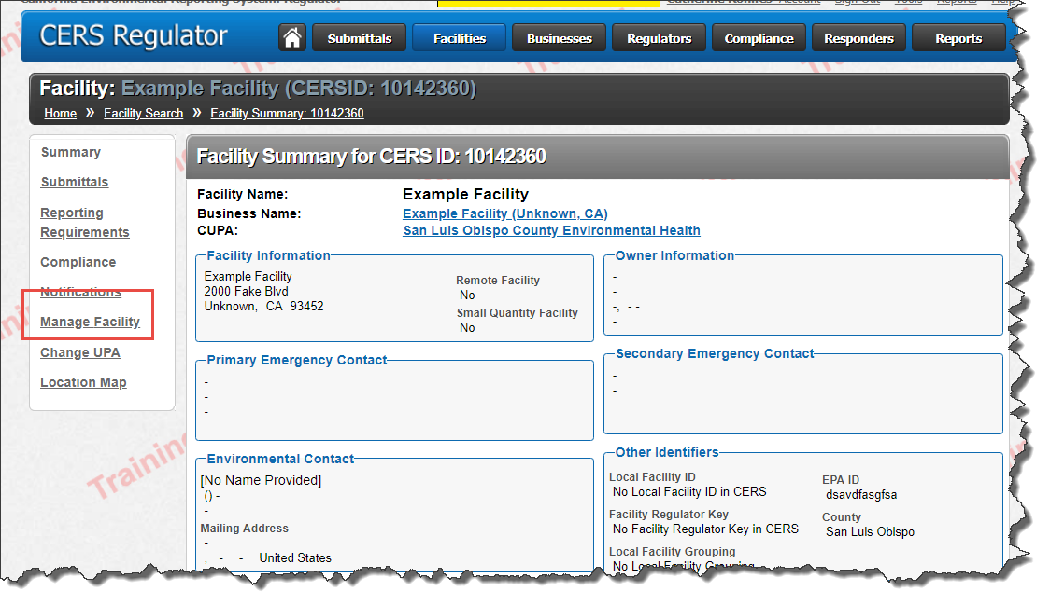
- Select ‘Transfer Facility to Another Business’
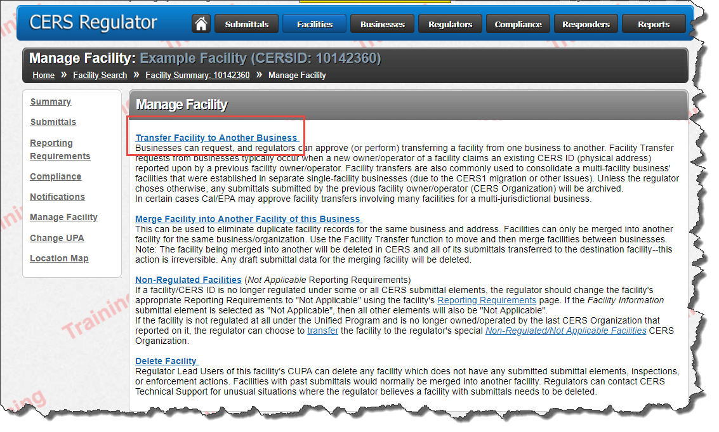
- Enter the ‘Organization Name’ (that you just created in the ‘CERS Business Portal’). Search ‘CERS Organizations’ Select the ‘Business/Organization Name’.
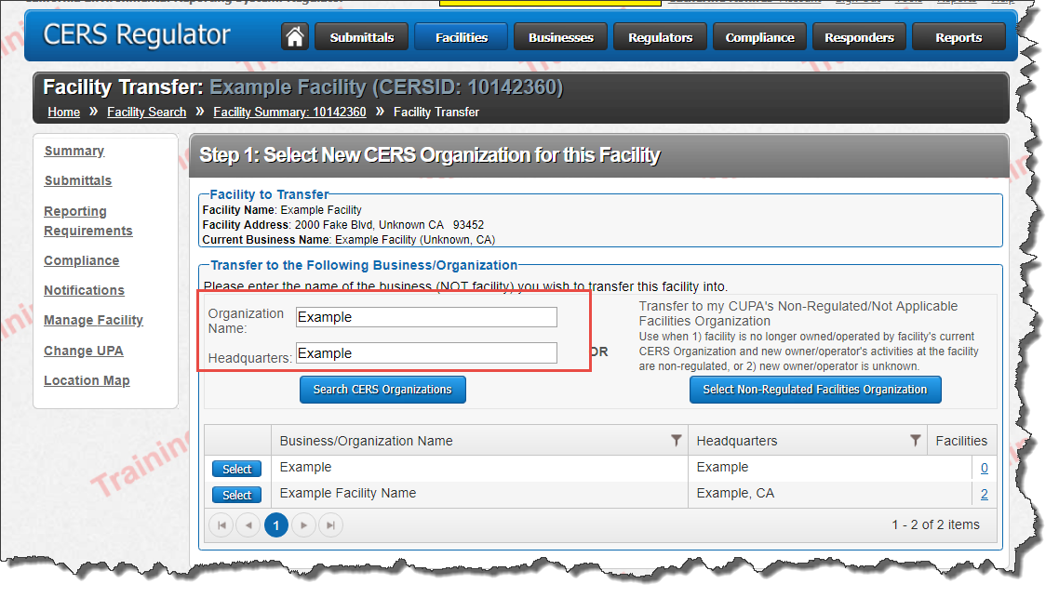
- Enter the ‘Regulator Approving Facility Transfer’ and ‘Comments’
Enter a ‘Check’ ‘Transfer Past Submittals (and any current drafts) to New Business/Organization:’
Select ‘Confirm’
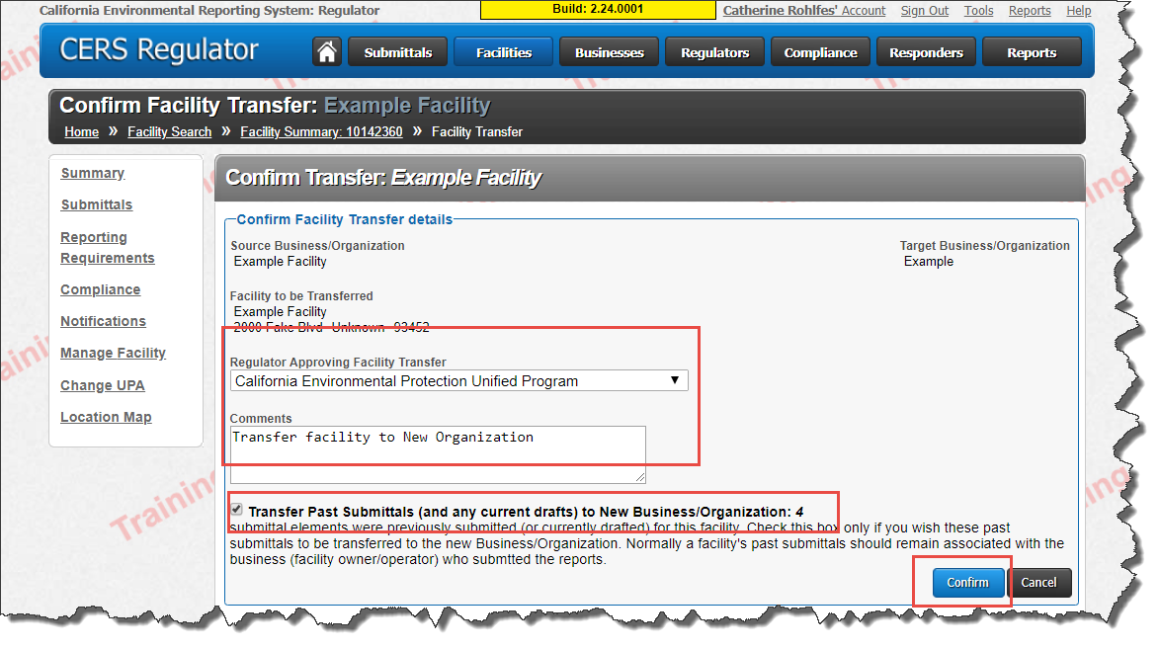
- Select ‘Done’
