How to create a CERS Testing Environment Account:
California Environmental Reporting System
CERS Regulator Portal Knowledge Base Help
http://cers.calepa.ca.gov/
- Open your web browser and navigate to the CERS Regulator Testing environment sign in page: https://cersapps.calepa.ca.gov/Testing/Regulator/Account/SignIn
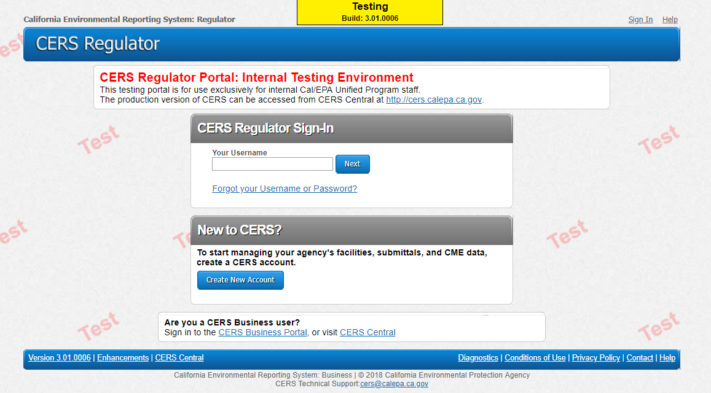
(example of screen CERS Regulator Portal Sign-In page)
2. Select the ‘Create New Account’ button from the ‘New to CERS’ section of the sign in page.
(Ensure “Test” watermark is displayed on the page background; Yellow “Testing” banner is displayed at the top of the page.) 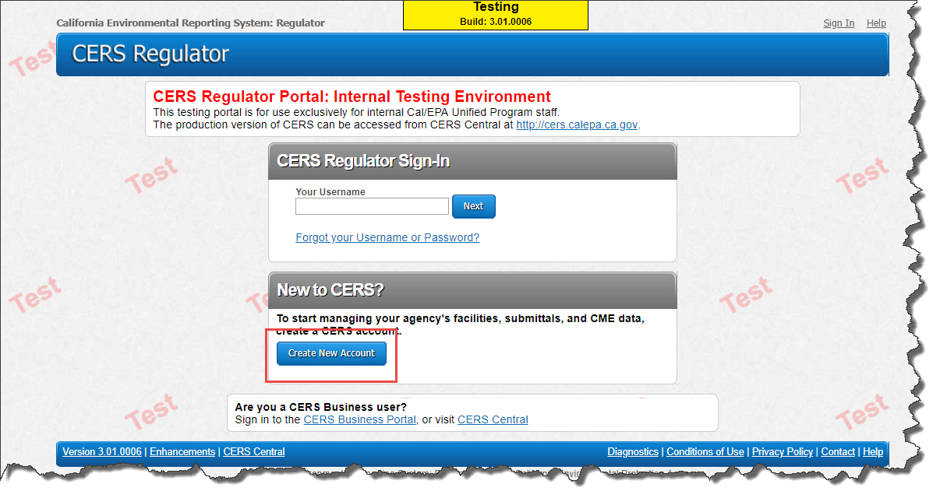
(example of screen for creating your CERS account)
3. Complete entries for all form fields, then select the ‘Create My Account’ button from the bottom of the page to continue.
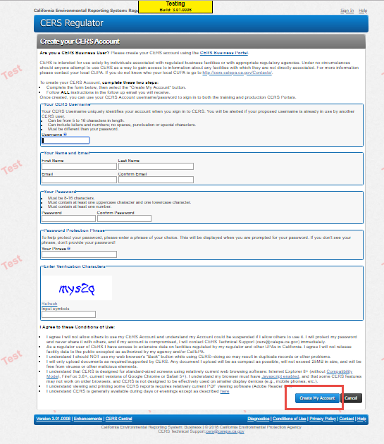
(example screen of Create your CERS Account)
4. Contact CERS Technical Support at: CERS@calepa.ca.gov and provide your name, email address, and account username for activation.
5. CERS Technical Support staff will respond with confirmation once testing account has been activated.
Please email cers@calepa.ca.gov if you have questions.

