CERS Test Portal - Sign into CERS Testing Portal https://cersapps.calepa.ca.gov/Testing/Business
CERS 3 Enhancements will be active in production in March 2019.
************************************************************************
- Select the Business Name, Select Save
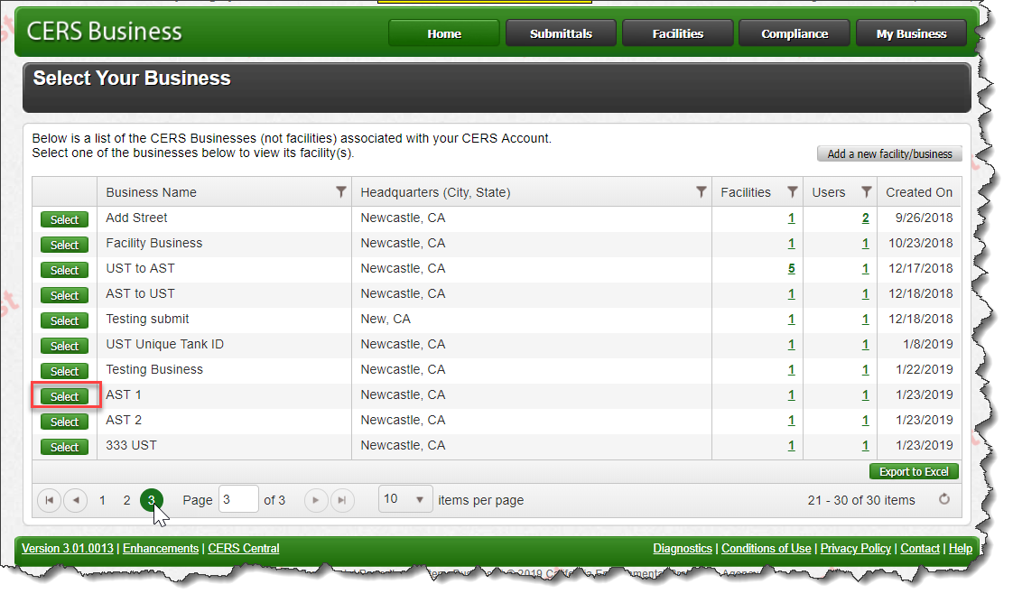
- Select Start / Edit Submittal, Select Save
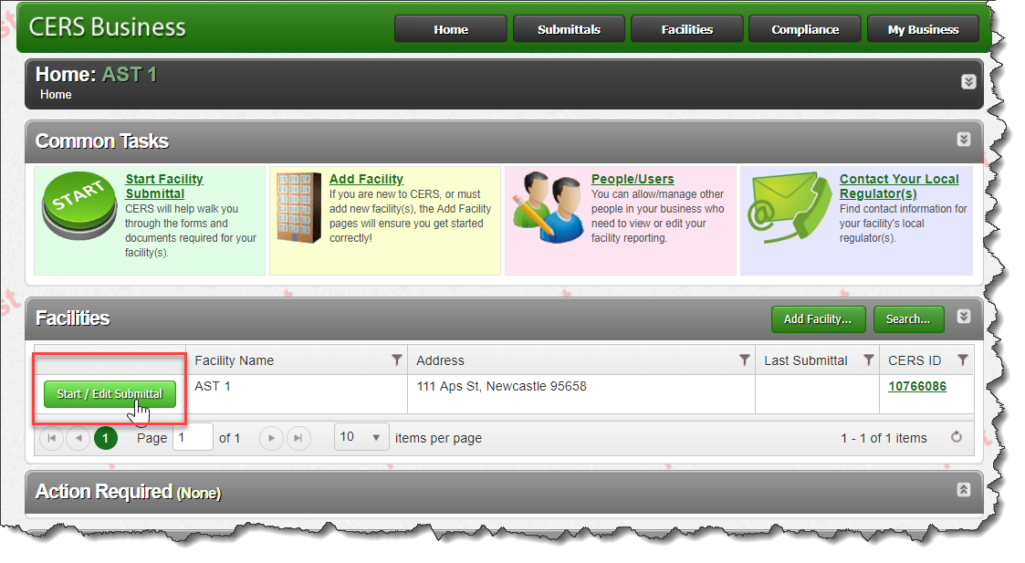

- Select Business Activities element
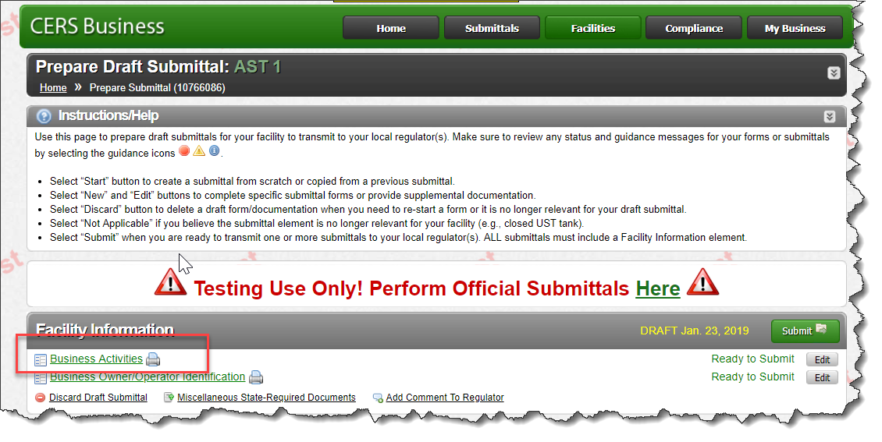

- Select Aboveground Petroleum Storage element
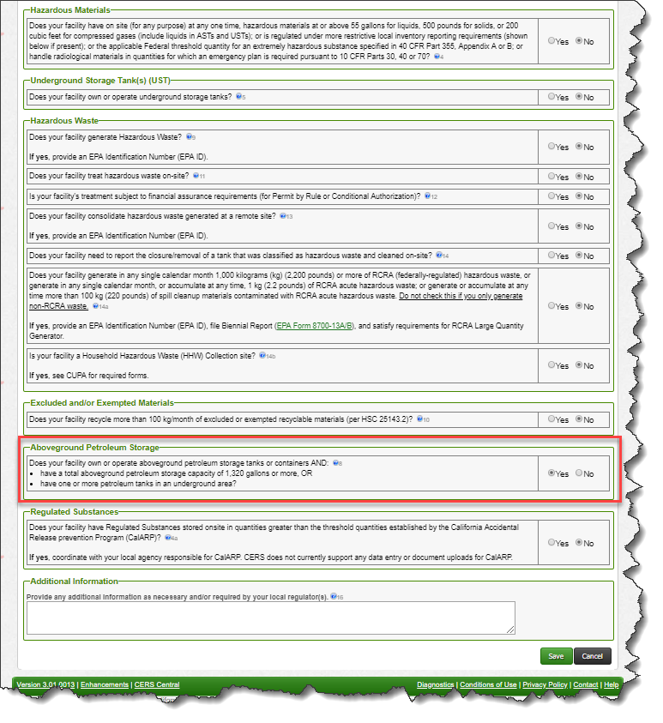

- Update the Business Owner/Operator Identification element
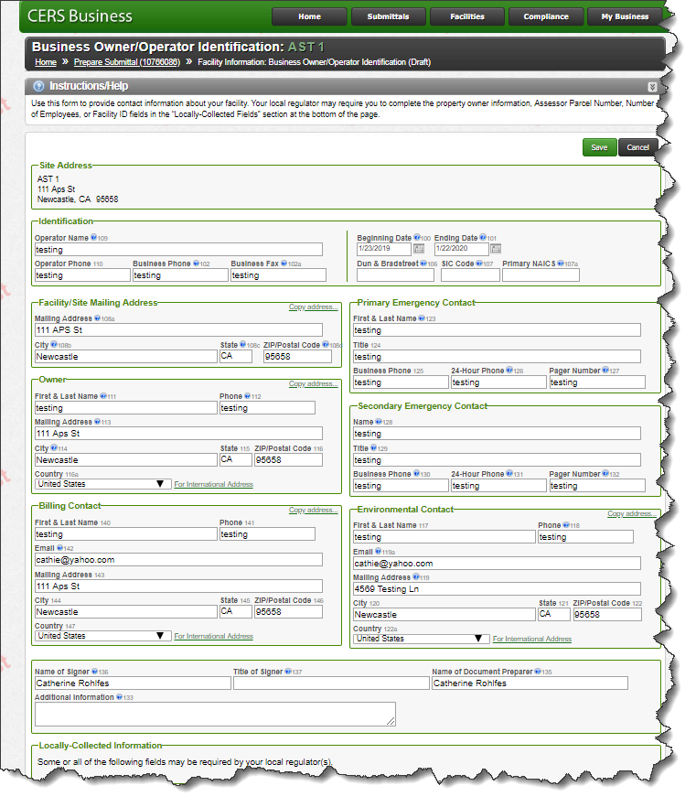
- APSA Facility Information
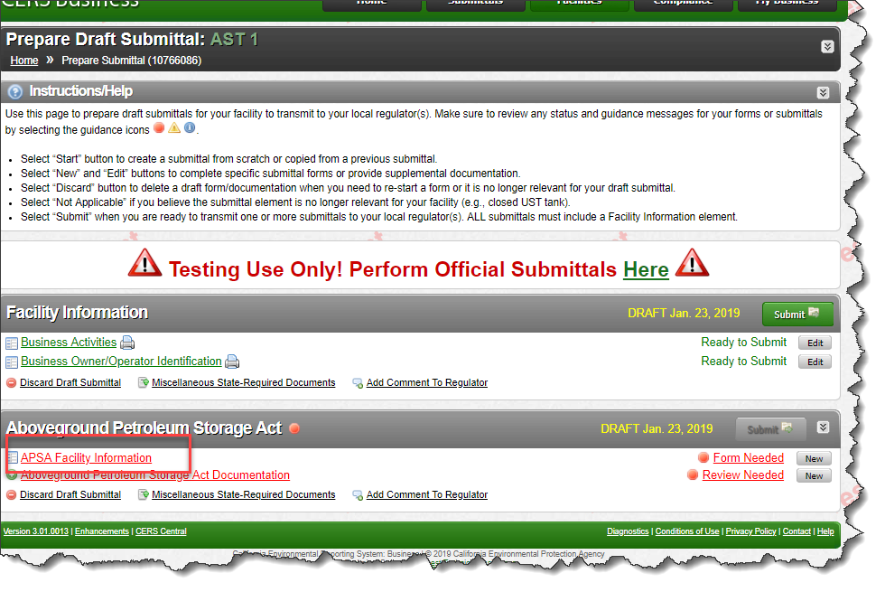

- APSA Facility Information:
Fields were added to capture Conditionally Exempt and Not Exempt
- Check the box than no additional information is requested on the APSA Facility Information.
- Do not check box if condition is not exempt and complete the fields.
  - Total Aboveground Petroleum Storage Capacity
  - Number of Tanks in Underground Area
  - Date of SPCC Plan Certification or 5 year review
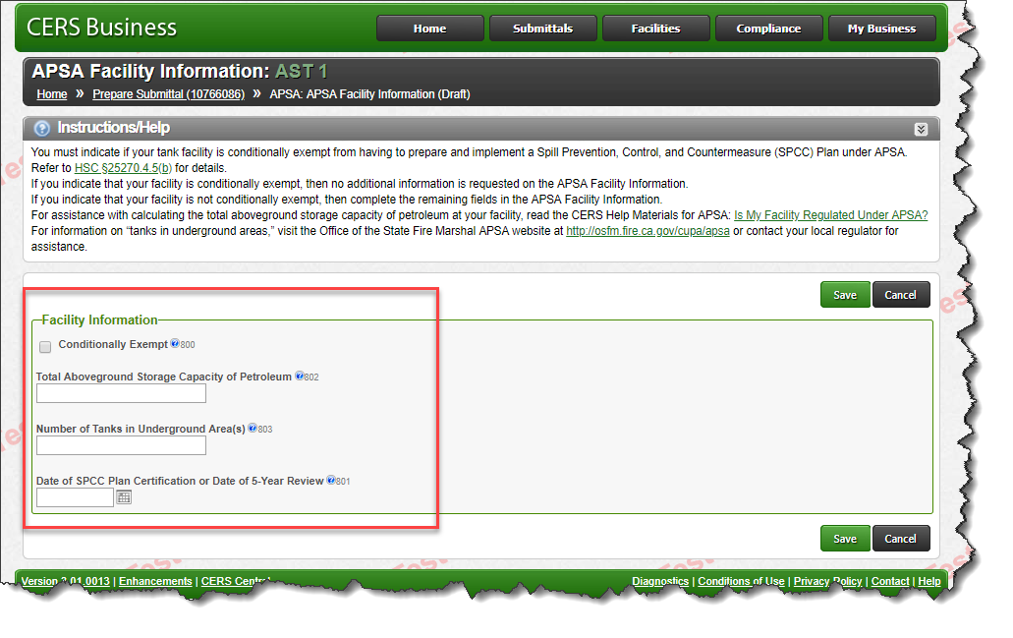

Regulated Portal - Aboveground Petroleum Storage Act (APSA) Report
California Environmental Reporting System
CERS Knowledge Base Help http://cers.calepa.ca.gov/
CERS Test Portal - Sign into CERS Testing Portal - https://cersapps.calepa.ca.gov/Testing/Business
