CERS 3 Enhancements
(Document that will be used at CUPA Conference for CERS 3 Lab)
Regulator Portal testing https://cersapps.calepa.ca.gov/Testing/Regulator/
Business Portal testing https://cersapps.calepa.ca.gov/Testing/Business
- APSA (Aboveground Petroleum Storage Act) Field
Enhancement Description:
- Modify Business Activities APSA question to include secondary question (Business Activities submittal element).
- Add Help button detailed text
- Added new APSA Field: Conditionally Exempt APSA Tank Facility (Valid Value Y or N).
- Business Activities Description/Usage (data element 8) updated.
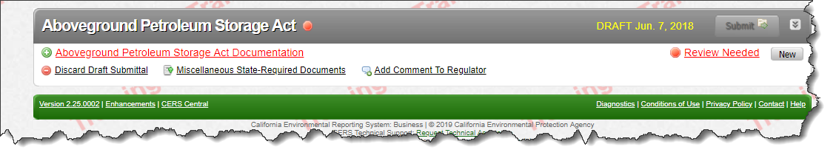
Enhancement 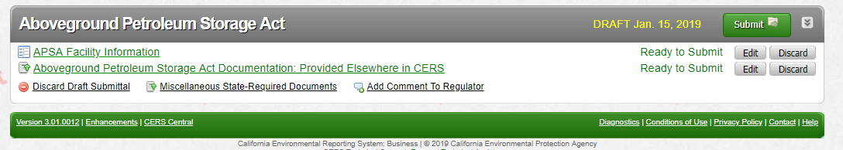
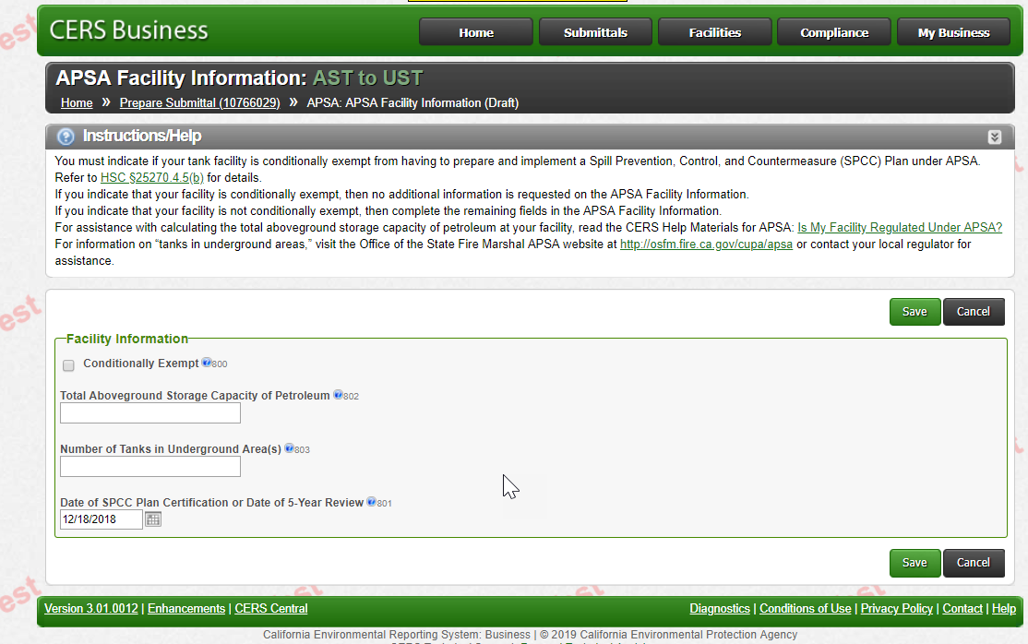
****************************************************************
- UST (Underground Storage Tanks) Split Facility
Enhancement Description:
- New value added for (data element 430) “Type of Action” transfers ownership of a tank to another business/facility.
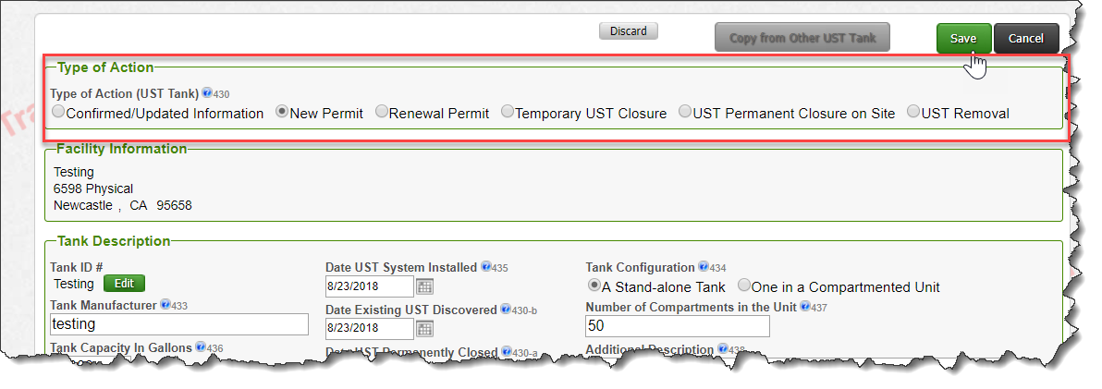

Enhancement 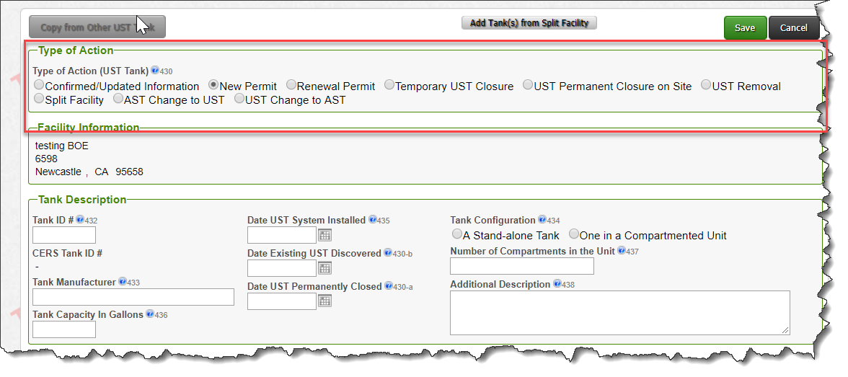

*******************************************************************
- UST Unique Tank ID
Enhancement Description:
- Created a new field to be use for unique UST Tank ID # for all NEW UST’s (data element 432).
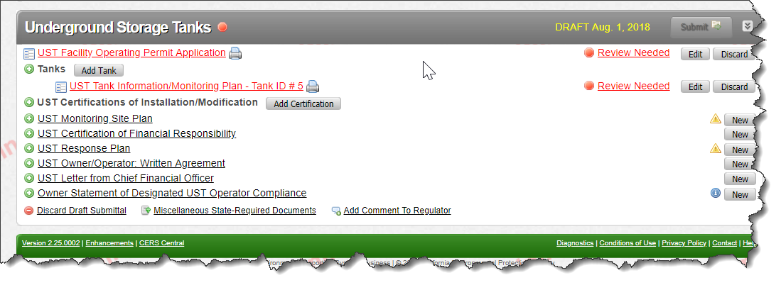
Enhancement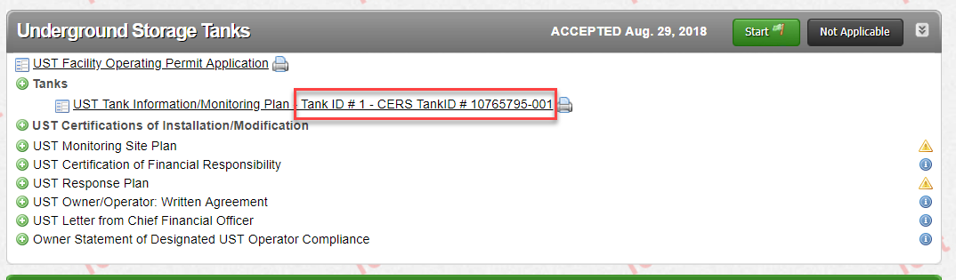

****************************************************************
- Underground Storage Tanks Submittals
Enhancement Description:
- Added New Data Element Codes for Data Element 439 – Tank Use
  - Airport Hydrant System
- Added New Data Element Codes for Data Element 440 – Tank Contents
  - E85
  - Biodiesel B6 – 899
  - Biodiesel 100
  - Kerosene
- Obsoleted Data Element Codes for Data Element 440 –
  - Petroleum Blend Fuel
  - Ethanol
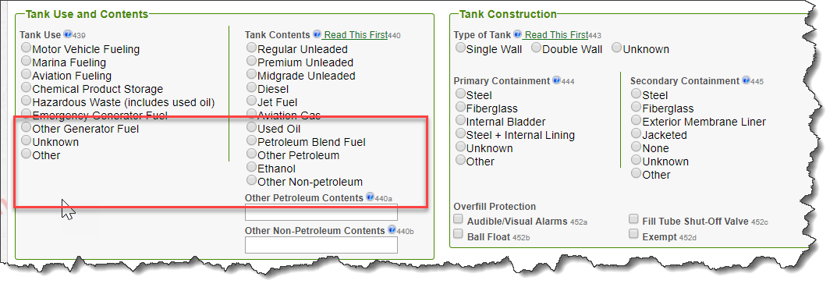
Enhancement
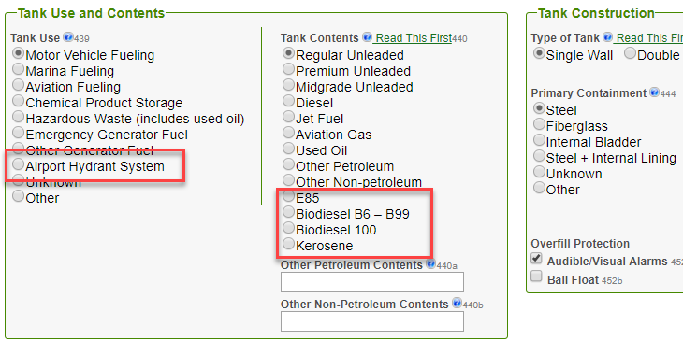

*******************************************************************
UST to AST
Enhancement Description:
- Create new Action items to track tanks that move from UST to AST and vice versa (data element 430).
- The SOC field and its associated data element codes are replaced by the TCR/Performance Meassures.
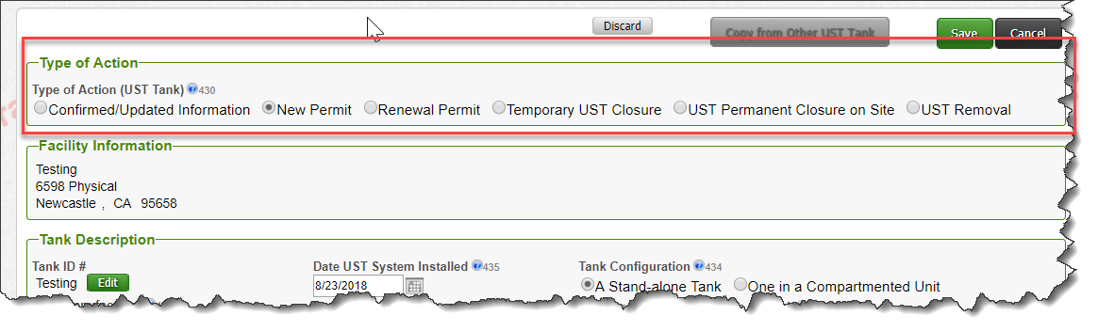Enhancement
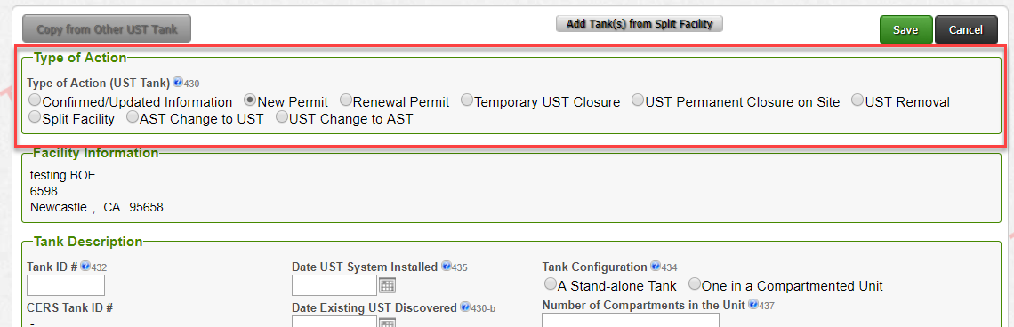

****************************************************************
- CME – Compliance, Monitoring and Enforcement
Enhancement Description:
- Added 36 NEW violations to Violation Library (New violations added to Violation Library (USEPATCH)
- Replaced the SOC (Significant Operational Compliance) field and its associated data element codes replaced by the TCR (Technical Compliance Rate) Performance Measures implemented in the Violation Library October 2018.
- Technical Compliance Rate - 9a,9d,9c,9d,9e when violation chosen TCR field will indicate ‘NO’ for not selected and ‘YES’
Enhancement
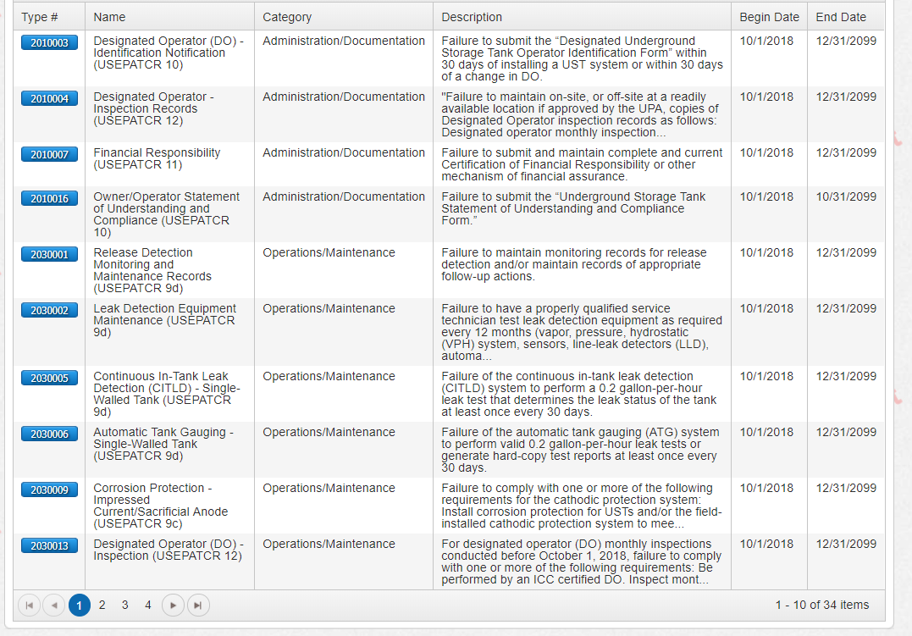

SOC (Significant Operational Compliance) field before 10/1/2018
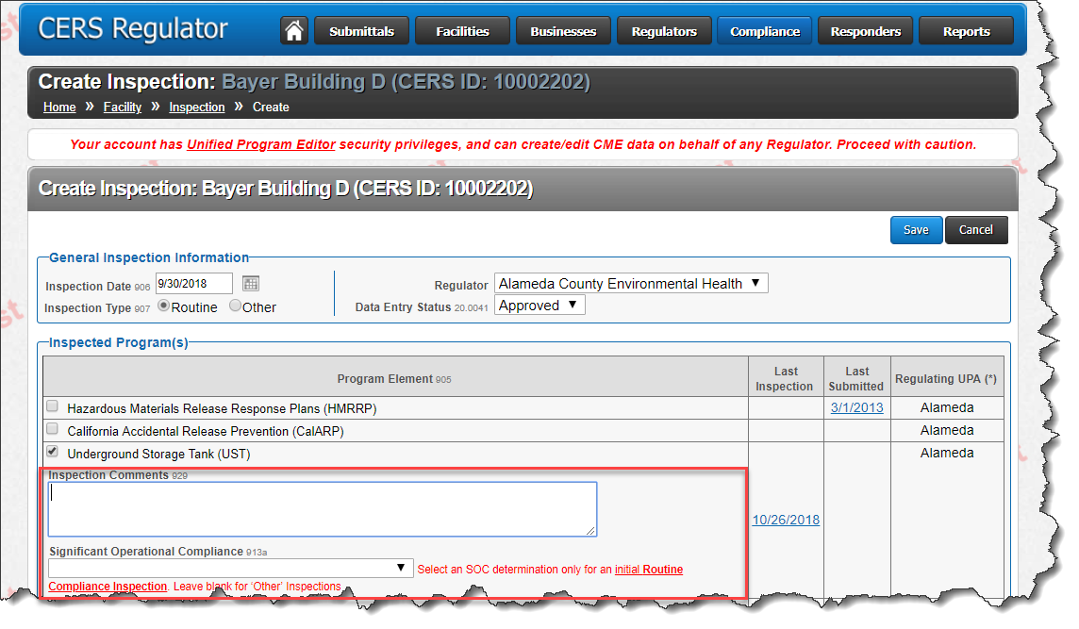
TCR (Technical Compliance Rate) field after 10/1/2018
Enhancement
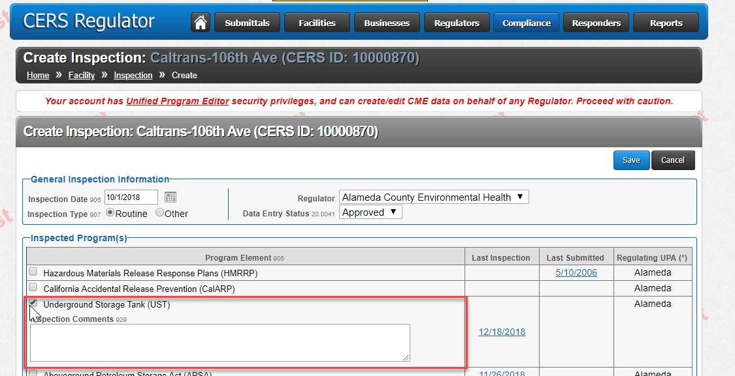
Enhancement
TCR (Technical Compliance Rate) – Yes
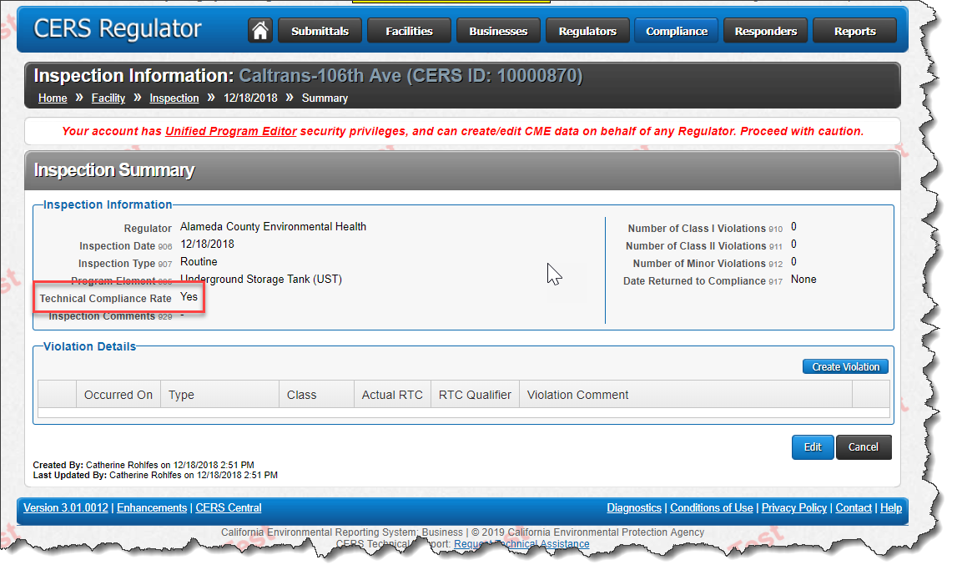
TCR (Technical Compliance Rate) - No
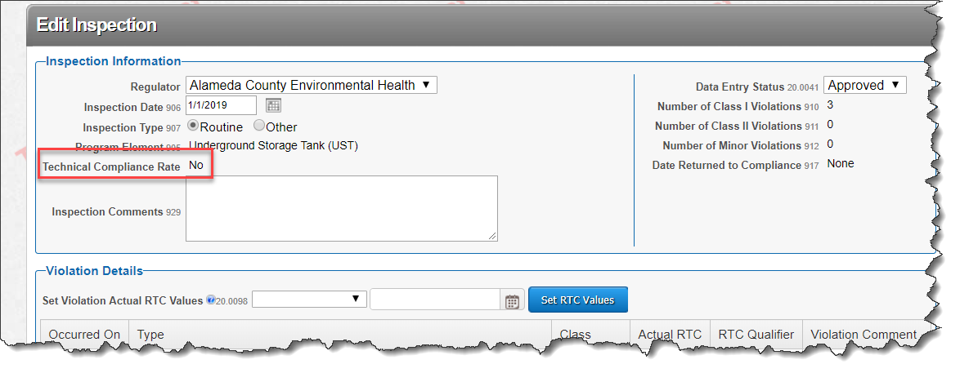
*************************************************************

BOE – (Board of Equalization Number)
Increase max field length from 8 to 9 digit
  - New UST facilities will use 9 digit number with no “44” prefix requirement as of July 2019
  - Existing facilities and State/Federal exempt facilities will retain existing BOE Numbers (44XXXXXX)
  - CERS will accept “44XXXXXX” or “XXXXXXXXX”

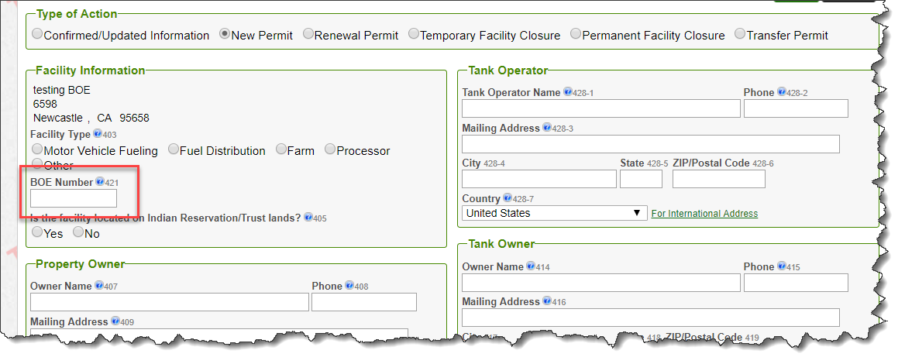
*************************************************************

- Reports
- APSA (Aboveground Petroleum Storage Act)Facility Information Report – Regulator portal
  - New Report created
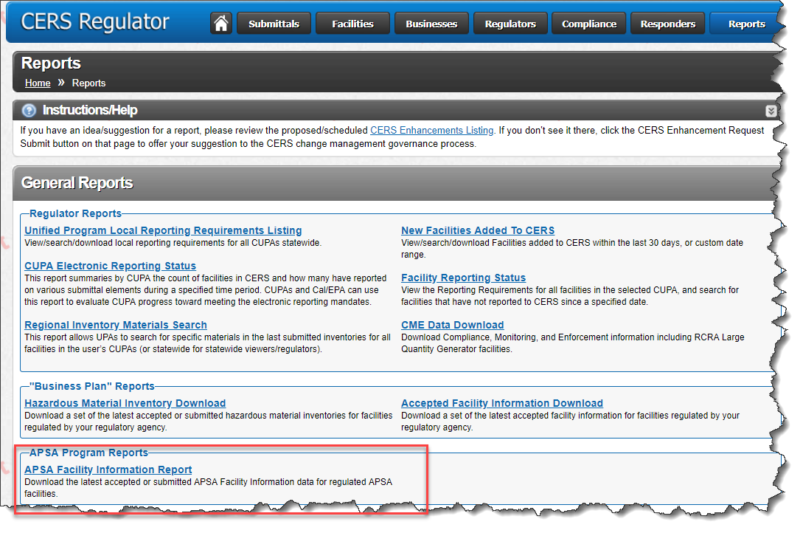
- Submittal Printing/New APSA and UST fields – Regulator and Business Portals
  - Add APSA and UST fields for printing options
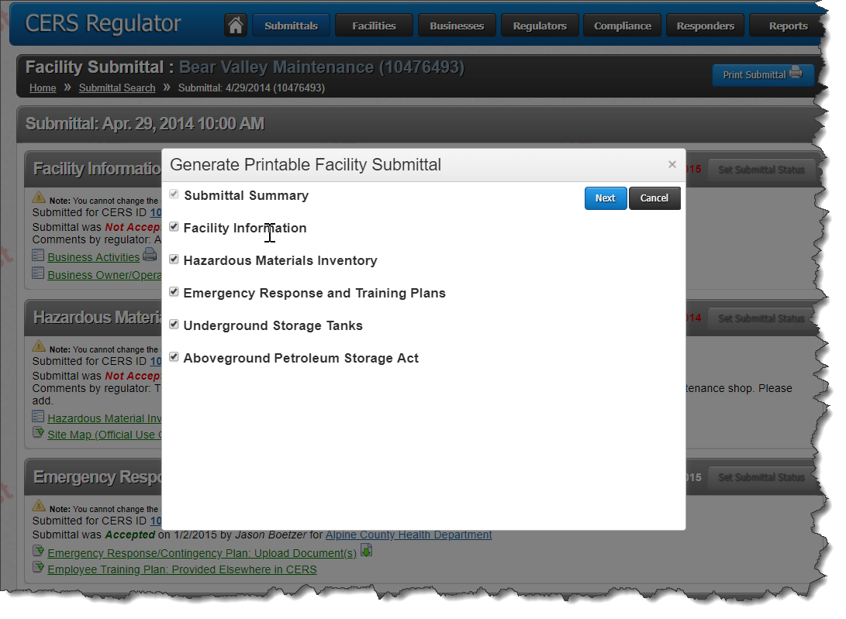

- Updated UST Report 6 for Performance Measures/Technical Compliance Rates – Regulator portal
  - Columns added
      - Petroleum Systems reclassified under APSA
      - Compliance Rate Determinations 9a,9d,9c,9d,9e
      - Significant Operational Compliance Determinations
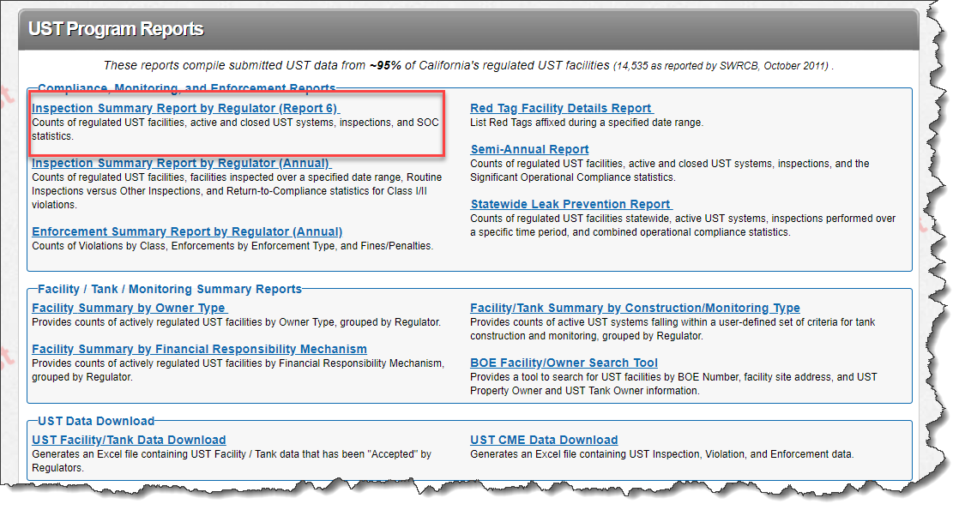
- Updated CME Data Download Report for CERS Tank ID and Performance Measures/Technical Compliance Rates – Regulator portal
  - Columns added report
      - Technical Compliance Rate
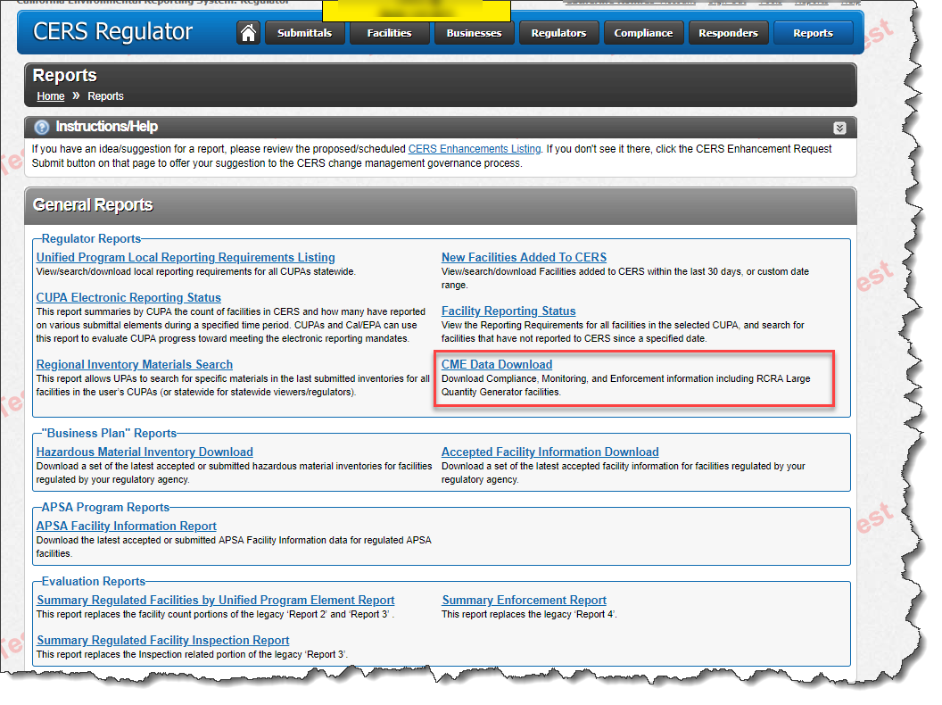

- Updated UST CME Data Download Report for CERS Tank ID and Performance Measures/Technical Compliance Rates – Regulator Portal
  - Columns added to report
    - Performance Measures
    - Technical Compliance Rates
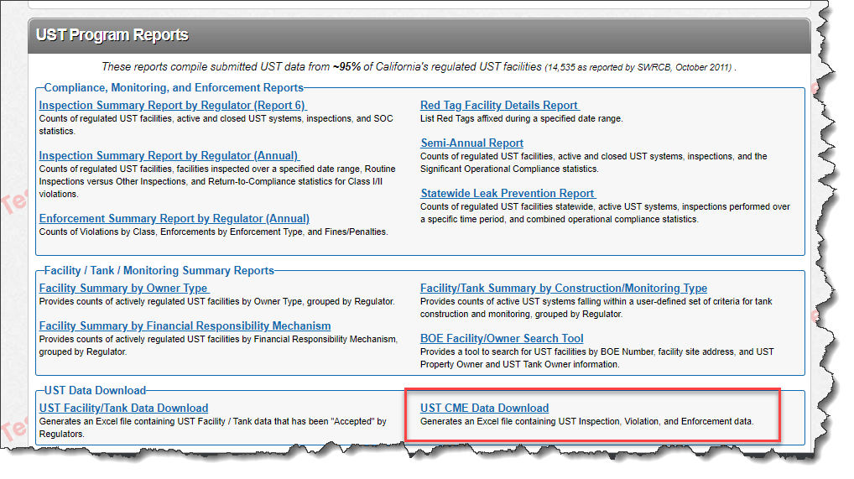

- Updated UST Facility/Tank Data Download Report for CERS Tank ID – Regulator portal
  - Columns added report
    - Technical Compliance Rates
    - UST Facility
    - Tank Data
