- Select Start/Edit Submittal, Edit the ‘Business Activities’, ‘Business Owner/Operator Identification’, ‘Emergency Response and Training Plans’, Select ‘Save’
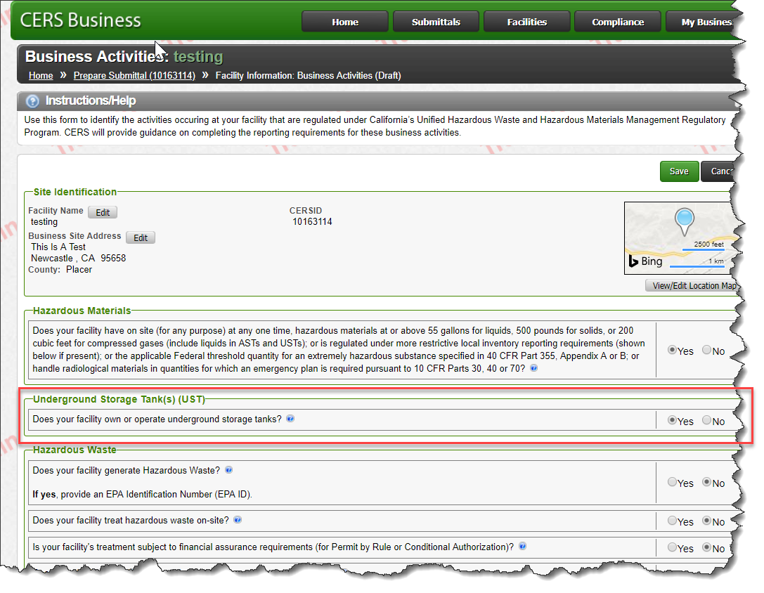
- Select ‘Underground Storage Tanks’ – ‘Add Tank’
- Enter tank ID # - Tank ID # is an identifying number that is created by the CERS User for tank tracking.
- Complete all other fields on screen pertinent to the facility.
- Select ‘Save’
- Complete ‘UST Monitoring Plan:’ Select ‘Save’

- Notice the Unique Tank ID# was assigned to the element (see screen below)
- Unique Tank ID will allow better tracking/reporting for USTs and reduce or eliminate occurrences of duplicate USTs in CERS
  - Tank ID will never change, even if the tank changes owners or facilities via Split Facility process
  - The number will be non-editable and can only be generated by CERS, similar to a facility CERS ID
  - Format: Current facility CERS ID + 3 digit incremental number
    - CERS ID 10023456 Tank 1: 10023456-001
    - CERS ID 10023456 Tank 2: 10023456-002

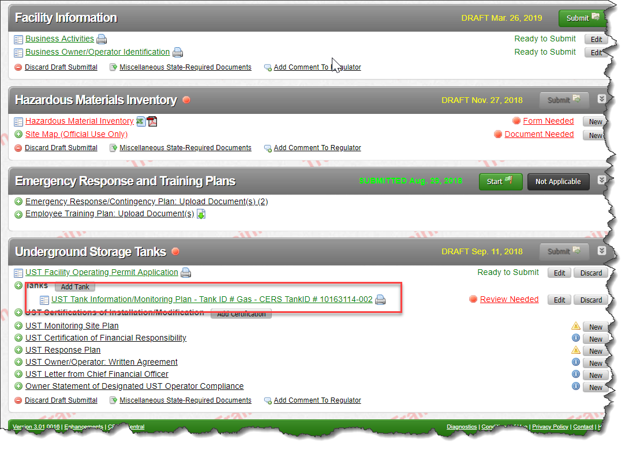
- Select ‘Save’ and complete remaining UST elements if necessary for reporting.

Process completed

